**Convolutional Neural Networks**

**University of Luxembourg**

***Sean Achtatou***

The Convolutional Neural Networks, is a Neural Networks based on the use of the Convolution on inputs data, a.k.a convolutional layer. The convolutional Neural Networks is mainly used in computer vision for Machine and Deep Learning to recognize different types of objects, people on images or simply digit – to solve problem based on spatial and temporal structure.

There exist different types of Convolutional Neural Networks with different architecture. For our project, we used the *YOLO* application, which is a CNN trained to be used for human, and objects detection. Nevertheless, the Convolutional Neural Networks operations mainly all follow the same architecture – convolution, padding (optional), pooling (optional), stride (optional), convolutional layers (filters), activation functions, fully connected Neural Networks.

We will deeply explain the “Convolution”, “Convolutional Layers”, “Neural Networks”, and “Activation Functions”.

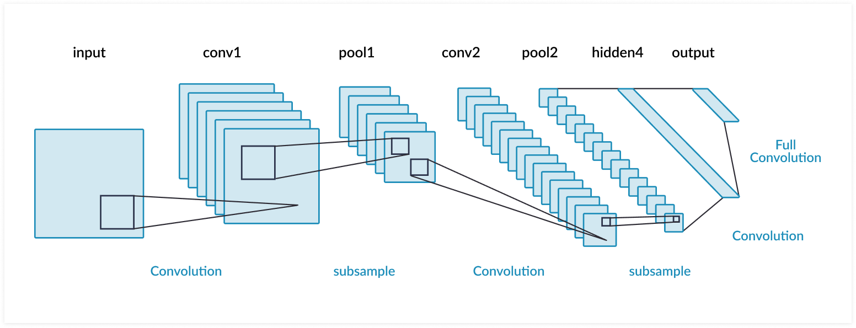

**_________________________________________________________________________________________________**

1. **Convolutional Architecture**
   1. **Convolution**

We can define the convolution as the modification and transformation of an input data to another output by the use of a filter, which is two by two matrices. The result is obtained by a mathematical operation between the input data and the filter, resulting into an output results.

The filters are used through each convolution steps, there are used to produce an output providing different information about the input data. There exist different types of filters, some can provide information about edge detection, other can just be identity matrix. The filters can be of different size (but each axis must be of the same size) but must always be inferior to the input data with which it will convolve.

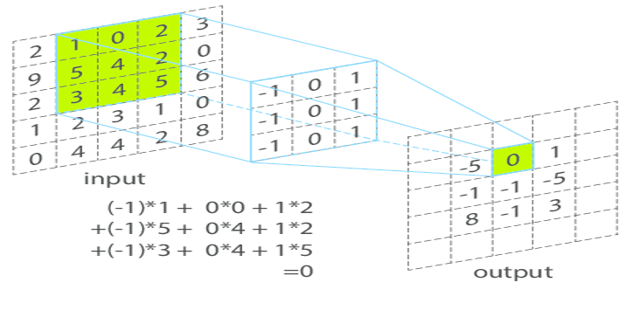

The Convolutional layers are a set of 2D (or 3D) filters equally equals in both axis, but smaller than the original input. With an input image, we can use the filters to convolve with the input, producing a new output by summing the element-wise multiplication of the input with the filters. There exists different type of filters, each filters have a different resulting pixels, some of filters will provide information about edge of the image while others will smooth the image. The numbers of filters depend on the amount of details we would like to obtain about the image, more filters lead to a better features representation of the input image to the CNN.

However, it could happen we would like, once the input data dimension convolved with the filter, to obtain an output with the same dimension. To solve this problem, we can add a padding to the input data, which is surrounding the data with zero’s. Thus, when the convolution will be processed, we would obtain an output with the same dimension.

To learn more about CNN : <https://medium.com/@RaghavPrabhu/understanding-of-convolutional-neural-network-cnn-deep-learning-99760835f148>

* 1. **Fully-Connected Neural Networks**

At some point, we would like to predict the results obtained by the Convolution and classify them. By only taking the features outputted from the CNN, how would we predict if those features belong to a human? A training (Machine Learning, Deep Learning) of a fully Connected Neural Networks, on multiples features, need to be done in order to predict the final classification. Most of the Neural Networks are based on returning a probability on multiples classes, and returning the class with the highest one.

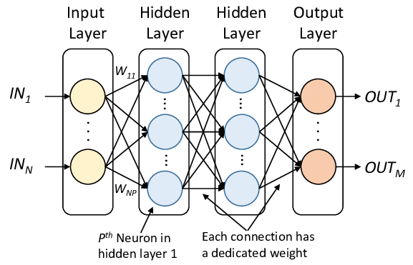

* + 1. **Activation Functions**

We have not talked about the activation function, but there are very important for the convolutional neural networks to work. The activation function will help the convolution to introduce a non-linearity to the data obtained. One of the most known and performant activation function is the ReLU, it will mainly transform all the negative values to zero and keep the others. However, we can have the possibility to use other different activation function based on the performance and the result we would like to obtain. In the Convolutional Neural Networks, the activation function ReLU can be used just after the convolution and before the pooling.

To have a prediction of our Convolutional Neural Networks, we need an activation function for each layers in the fully connected neural networks as well. The activation function will provide how the different layers and the neural networks will predict the output. We can use ReLU for each hidden layers and Softmax for the output layer.

* + 1. **Train Neural Networks**

The fully Neural Networks is based on, settings and re-defining weights using back-propagation and gradient descent to optimize its prediction power. This is mainly used to minimize the loss accuracy of our trained model and obtain a better prediction of the data.

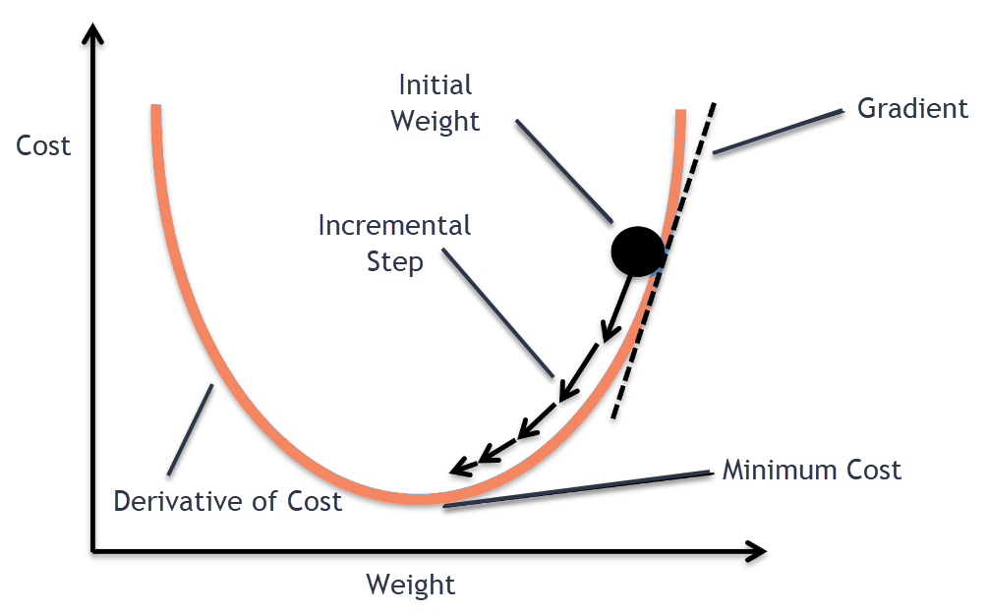

The following gradient descent is used to optimize the model:

$$w_{t+1}=w_{t}+∝.∇J\left(x\right)$$

$w_{t} :$ initial weight

$w_{t+1}$: new calculated weight

$∝ :$ speed at which the weights are changing

$∇J\left(x\right)$**:** calculate the direction the weights have to modified (positive or negative)

To learn more about optimization : <https://medium.com/yottabytes/everything-you-need-to-know-about-gradient-descent-applied-to-neural-networks-d70f85e0cc14>

***Sources:***

[1]<http://neuralnetworksanddeeplearning.com/chap1.html#complete_zero>

[2]<https://ujjwalkarn.me/2016/08/11/intuitive-explanation-convnets/>

[3]<https://victorzhou.com/blog/intro-to-cnns-part-1/>

[4]<https://medium.com/@RaghavPrabhu/understanding-of-convolutional-neural-network-cnn-deep-learning-99760835f148>

[5]<https://www.youtube.com/watch?v=vT1JzLTH4G4&list=PL3FW7Lu3i5JvHM8ljYj-zLfQRF3EO8sYv&index=2&t=0s>

[6]<https://pjreddie.com/darknet/yolo/>

[7]<https://github.com/wizyoung/YOLOv3_TensorFlow>

[8]<https://medium.com/the-theory-of-everything/understanding-activation-functions-in-neural-networks-9491262884e0>

[9] <https://en.wikipedia.org/wiki/Activation_function>

<https://missinglink.ai/guides/convolutional-neural-networks/convolutional-neural-network-architecture-forging-pathways-future/>

<https://perso.esiee.fr/~perretb/I5FM/TAI/convolution/index.html>

<https://www.researchgate.net/figure/Illustration-of-a-fully-connected-neural-network_fig2_333336147>